EXECUTIVE SUMMARY
Bangladesh Betar Audio Archive Platform
A National Digital Audio Asset Management, Preservation, Production, Rights Management and Distribution Platform
Prepared for: Bangladesh Betar
Prepared by: CraftCode
Document Type: Business & Functional Executive Summary
Date: July 2026

1 Introduction & Purpose
Bangladesh Betar, the national public radio broadcaster, holds decades of audio heritage across music, drama, news, documentaries, and regional programming, currently spread across physical tapes, disconnected drives, and informal digital folders. This executive summary presents the business case and functional direction for a unified Bangladesh Betar Audio Archive Platform, a national-scale system that will digitize, preserve, manage, and distribute this content while enabling modern services such as podcasts, streaming, and mobile access.
This document distills the complete functional specification into a concise, decision-ready overview for leadership, summarizing the platform's purpose, scope, capabilities, governance model, delivery roadmap, and success measures.

2 Project Overview
The platform will serve as a single, centralized system for storing, preserving, editing, searching, managing, distributing, and analysing all forms of Bangladesh Betar audio content, including songs, radio programmes, podcasts, the Bhoot FM archive, news, drama, historical recordings, speeches, advertisements, jingles, and live broadcasts.
A core architectural principle runs through the entire design: the original master recording is never altered. All editing, broadcast, and publishing activity produces new versions, while the master remains protected for long-term national preservation.
Guiding Principle
Preserve first, produce second. Every broadcast-ready, web, mobile, or social-media version is derived from a protected master copy — never a replacement for it.

3 Business Objectives
The platform is designed to deliver the following measurable outcomes for Bangladesh Betar:
Objective | Business Value
Digital preservation of historical audio | Safeguards national cultural and broadcast heritage against physical decay
Unified search across all content types | Reduces time spent locating archive material from hours to seconds
Single system for songs, podcasts and programmes | Removes fragmented workflows across departments and stations
Listening heat-maps and play analytics | Gives producers and marketing teams evidence of audience engagement
Non-destructive editing | Protects master recordings while enabling continuous re-use
Multi-channel content preparation | One upload feeds FM broadcast, web, mobile app, podcast platforms and social media
Rights, copyright and expiry control | Reduces legal exposure and enforces licensing compliance automatically
Full audit trail of all activity | Establishes accountability and transparency for a public institution
Bangla and English interface & metadata | Serves both national and international/research audiences
Searchable marketing voice library | Speeds up campaign production for the marketing team

4 Governance & User Roles
Access to the platform is controlled through ten purpose-built roles, ensuring that every archival, editorial, and administrative action is performed by an authorized user and is fully traceable.
Role | Primary Responsibility
Super Administrator | System-wide configuration, users, storage and disaster recovery
Archive Administrator | Collection management, classification, retention policy
Audio Archivist | Digitization, metadata entry, quality control, restoration notes
Audio Editor | Non-destructive editing and broadcast/online version creation
Programme Producer | Programme series, episodes, playlists and performance review
Podcast Manager | Podcast channels, seasons, episodes, RSS feeds and analytics
Music Library Manager | Song, artist and album metadata, licensing checks
Marketing & Promotion User | Voice search, jingles, campaign audio and usage tracking
Approver | Review and approval of uploads, edits, publication and broadcast
Viewer / Researcher | Search and preview of permitted archive content

5 Core Platform Capabilities
The functional specification defines 34 detailed modules. For executive purposes, these are grouped into eight capability pillars:

5.1 Content categories module
This module defines the classification backbone for everything that enters the Bangladesh Betar Audio Archive Platform. Rather than treating audio as one undifferentiated blob, it splits content into five distinct types — songs, podcasts, event/archive recordings, marketing voice assets, and radio programmes — each with its own metadata schema, because a folk song, a decades-old archived interview, and a commercial voice-over need fundamentally different fields to be findable and reusable later.
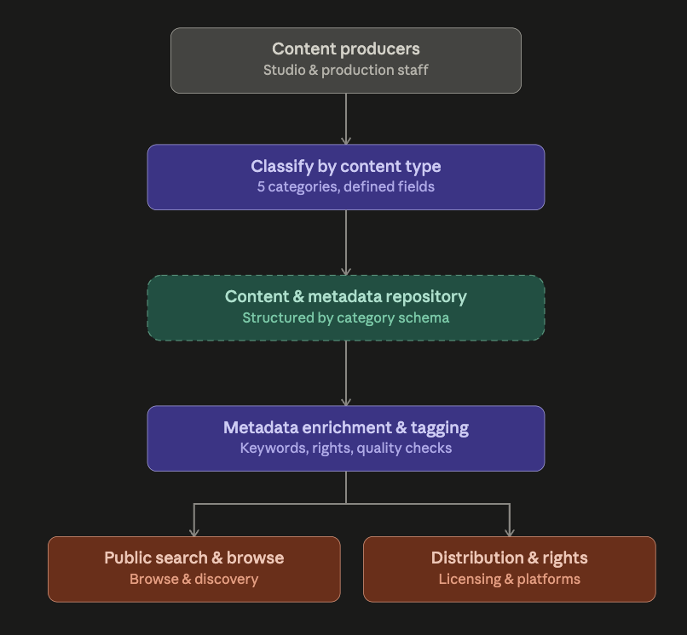

5.2 Audio upload and ingestion module

This module is the front door of the entire archive: every piece of audio, whether it's a decades-old reel-to-reel digitization or a live 24/7 channel feed, has to pass through it before it becomes a usable, searchable asset. It's built around three ideas — flexibility of intake, automated quality gatekeeping, and zero-touch metadata capture.
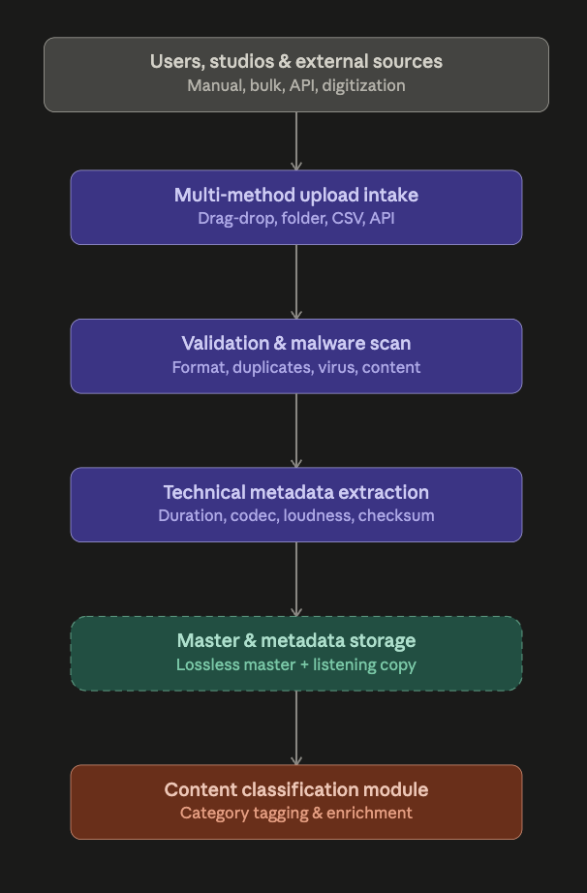

5.3 Audio digitization module

This module exists to rescue Bangladesh Betar's physical-format history — reel-to-reel, cassette, DAT, MiniDisc, vinyl, CD/DVD, and old digital formats — before it degrades further, and to do it in a way that's auditable and archive-grade rather than just "someone transferred a tape to MP3."

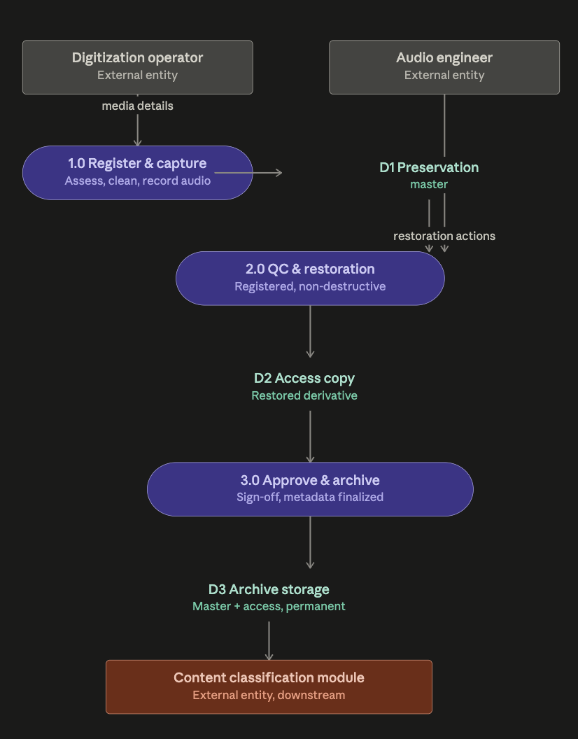
5.4 Master File and Version Management module Every asset maintains six distinct versions branching from one untouchable source: a preservation master (never overwritten, restricted access) that all derivatives — production master, broadcast, online, preview, and social-media versions — trace back to, each carrying its own version number, source lineage, creator, approval status, and usage purpose.

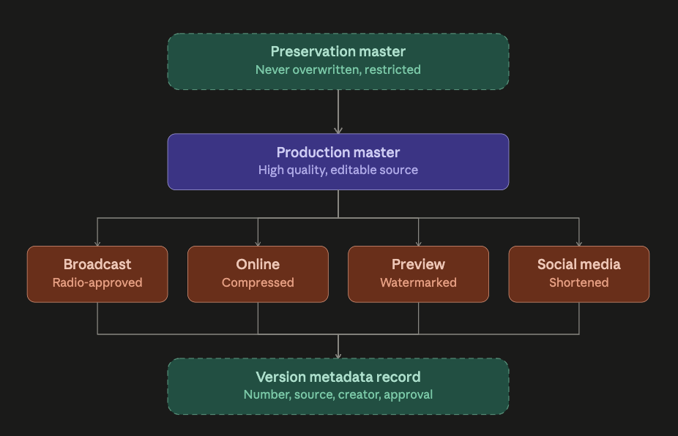

5.5 Song / podcast / event management module
This is the largest content-operations module in the platform — it's where raw digitized or uploaded audio actually becomes broadcast-ready, discoverable, and monetizable content across three distinct content

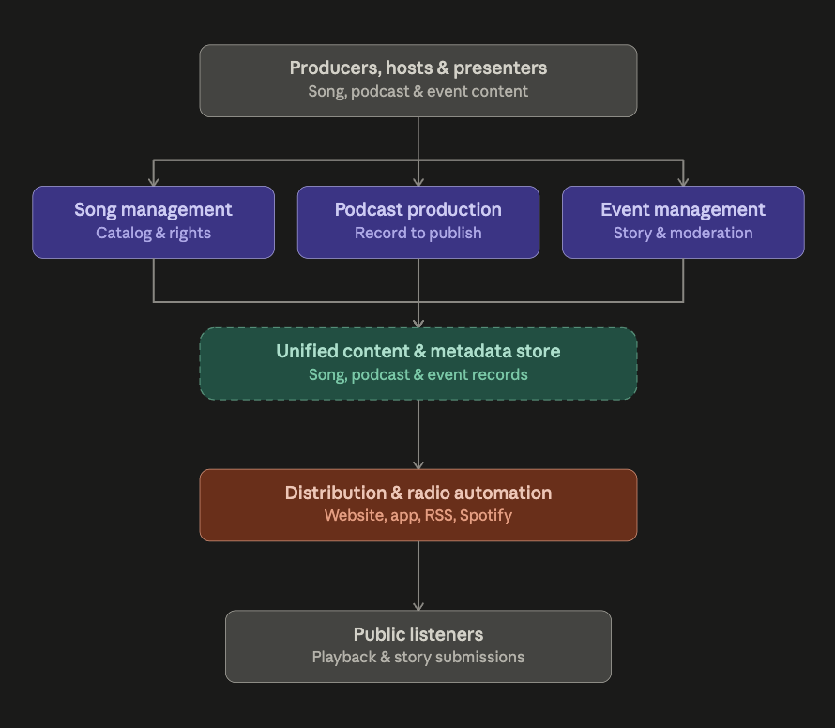

5.6 Editing module This module gives authorized users a full production audio editor — waveform view, trim, fades, noise reduction, censoring, jingles/station IDs, mono-stereo conversion, and more — but its defining constraint is the same one that runs through the whole platform: the original master is never touched.

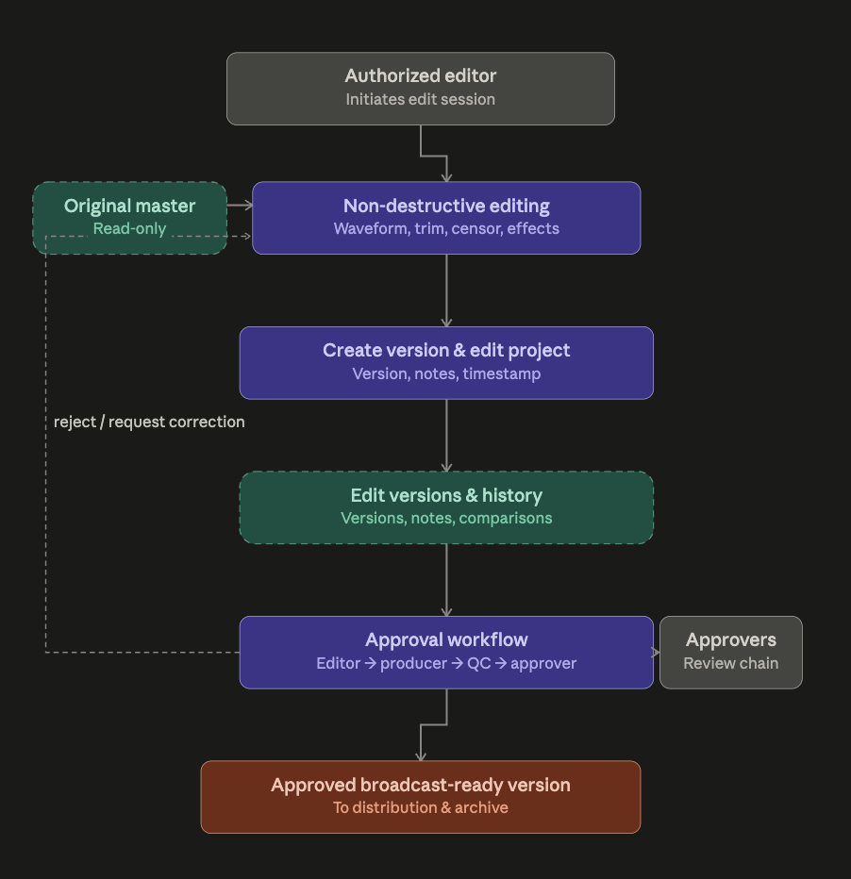

5.7 Audio player module

This one's mostly a client-side interaction surface, so the data flow is really about what the player reads (audio, waveform, transcript) versus what it writes back (favorites, playlists, playback history, heat-map data, download requests, and problem reports).

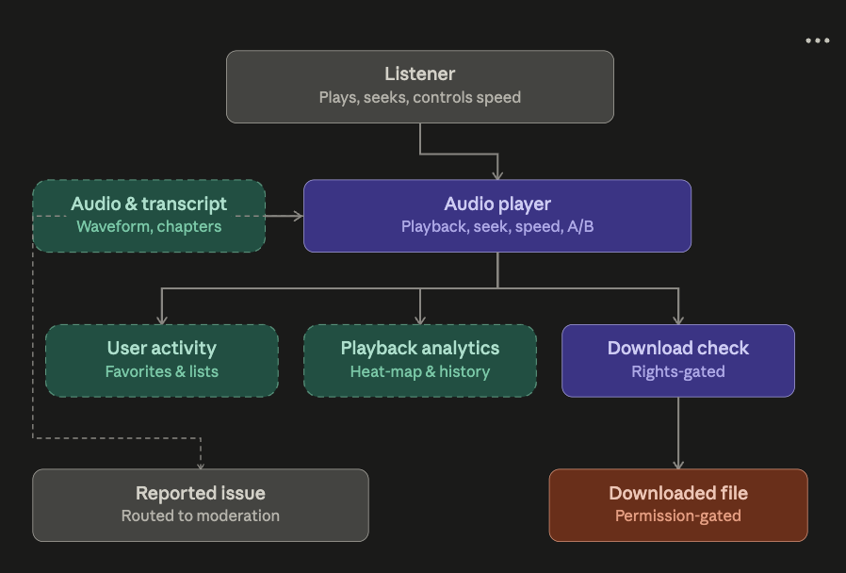

5.8 Listener analytics and heat map module.

This module turns raw playback behavior into two things Bangladesh Betar actually needs: a per-asset engagement picture (the heat map) and an organization-wide performance view (the dashboards). It's fundamentally an events-in, insights-out pipeline.

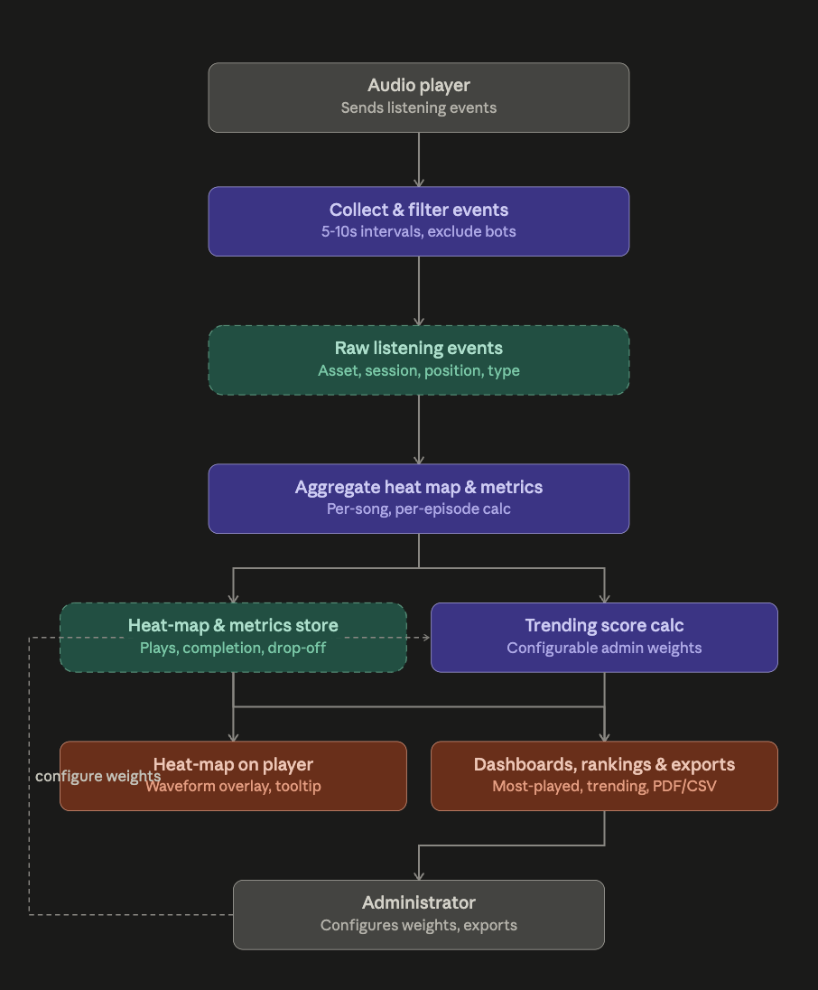

5.9 Most-played dashboard module

This module is the presentation layer on top of the analytics engine from the previous module — it doesn't collect new data, it aggregates what's already tracked (heat-map/metrics store) with catalog and rights data into ranked, filterable, card-based views.

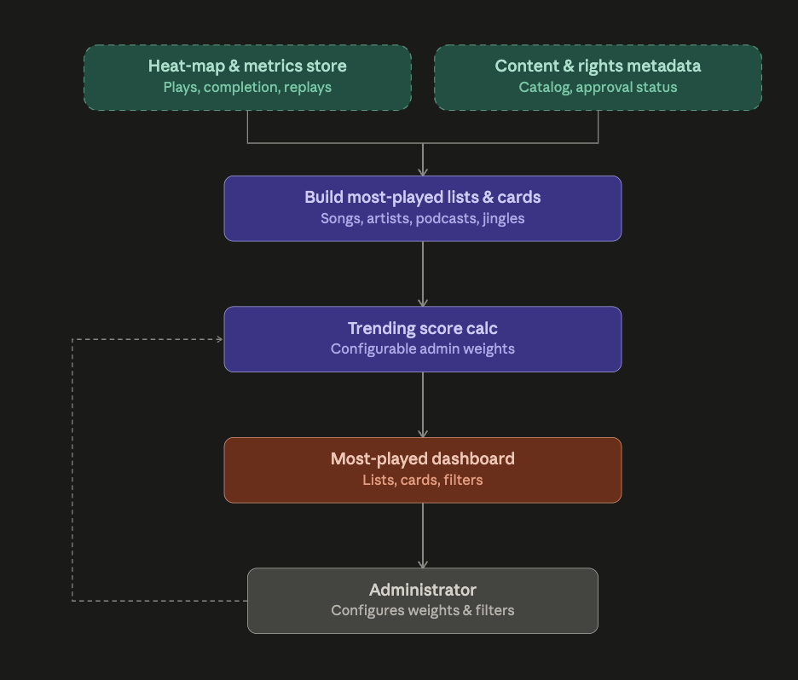

5.10 Marketing voice module

This module runs Bangladesh Betar's commercial voice-talent library and campaign production as its own self-contained workflow: search and audition voice artists (by language, accent, tone, style, availability), shortlist and get approval, build the actual campaign around a chosen script/voice/music/jingle combination, get client and management sign-off, produce platform-specific masters (radio/TV/social), and then actively track usage-rights periods with expiry alerts

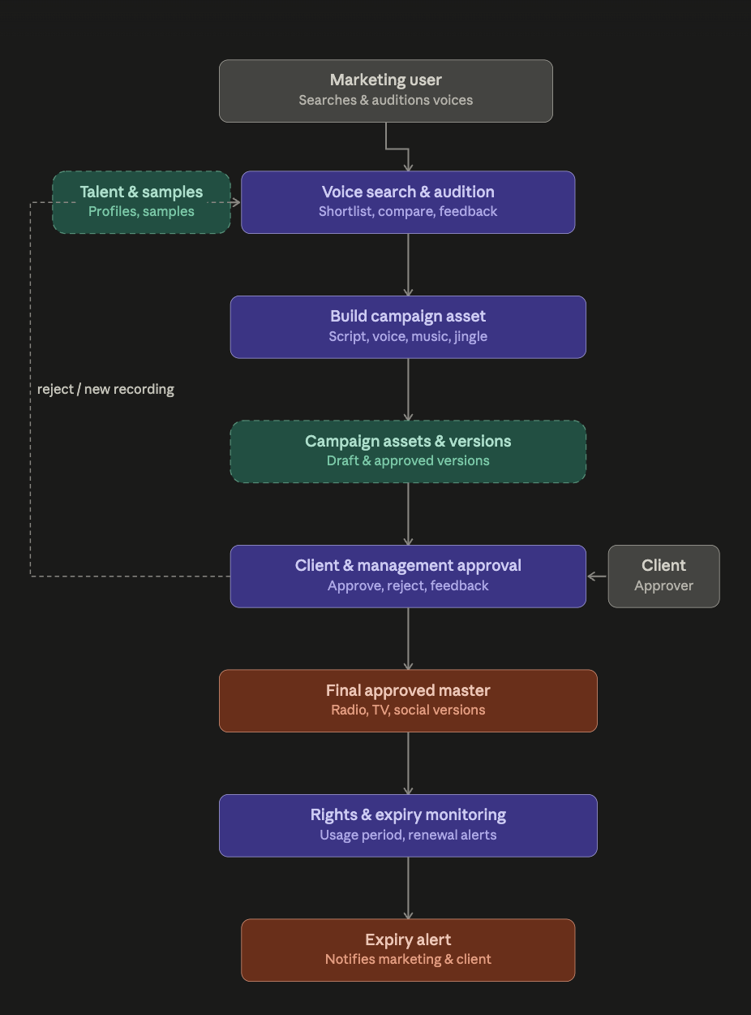

5.11 Metadata management module

This module is what turns the archive from "we have the audio somewhere" into "find it in seconds." It layers three distinct search capabilities

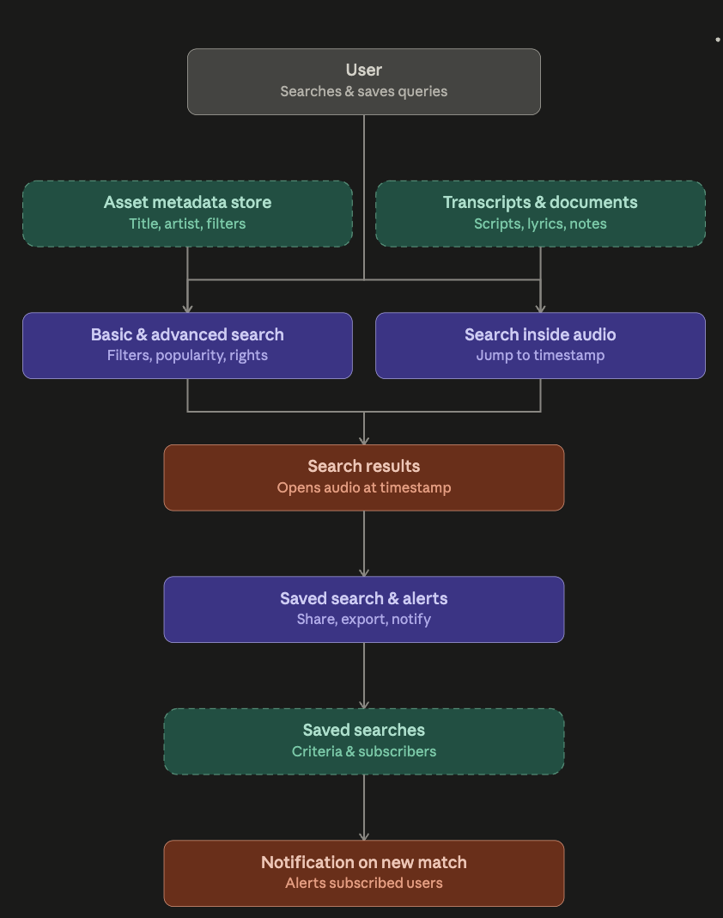

5.12 Marketing voice / voice-over feature

This is a fuller build-out of the marketing voice module, adding three things the earlier version didn't cover in depth: script governance (create, version, assign, annotate pronunciation for difficult Bangla or foreign words, get approval, then lock the script so recorded audio can be compared against it), watermarked audition previews with full take-tracking (multiple takes stored, approved/rejected history maintained, not just a single "final" file), and multi-trigger expiry monitoring — the system needs to separately watch usage-rights expiry, campaign end dates, commercial license renewal, voice-artist agreement expiry, and mandatory ad takedown, since these are five distinct legal/contractual clocks that don't all expire together. Everything still funnels through the same internal-plus-client approval gate before a final master (with radio/TV/social/short/alternate versions) is produced.

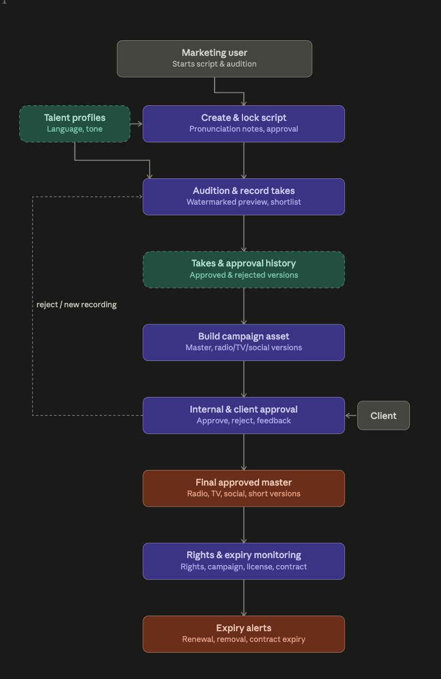
5.13 Playlist and Broadcast Preparation
This module lets programming staff build and validate broadcast playlists — drag-and-drop arrangement, scheduled start times, jingles/IDs, and automatic checks for missing files, rights issues, and duplicates — before sending them for approval and export to on-air broadcast systems.
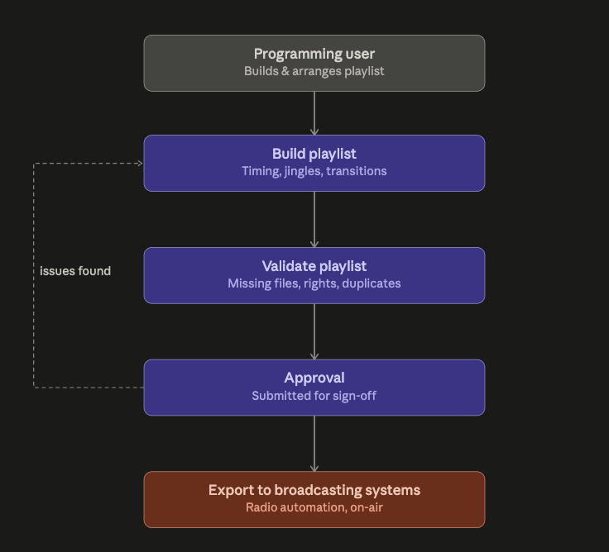

5.14. Copyright and rights management module

This module attaches a full rights profile to every asset — owner, performer/composer/lyricist rights, broadcast/online/podcast/social distribution rights, geographic restrictions, and contract dates — and then actively enforces it: blocking unauthorized publication or restricted downloads, flagging expired content, warning before expiry, and surfacing rights status directly in playlists.

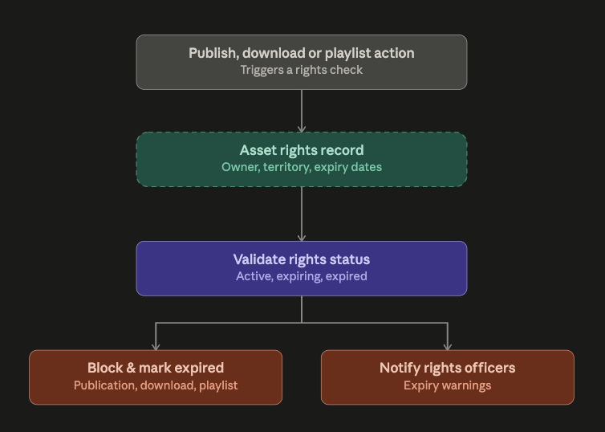

5.15 Quality- Control Module Quality
This module has quality controllers review each audio version for technical issues (clipping, noise, distortion, loudness, metadata errors, corruption, broadcast compatibility) and assign one of five statuses, with a QC report stored against every version.

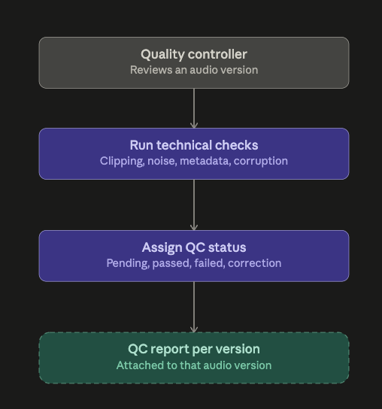

5.16 AI-Powered Intelligence
Artificial intelligence supports speech-to-text transcription, automatic summarization, tagging of people/places/topics, audio fingerprinting for duplicate and rights detection, and automated audio-quality analysis (silence, clipping, noise, corruption). All AI output is clearly marked as machine-generated and reviewed by a human before publication.
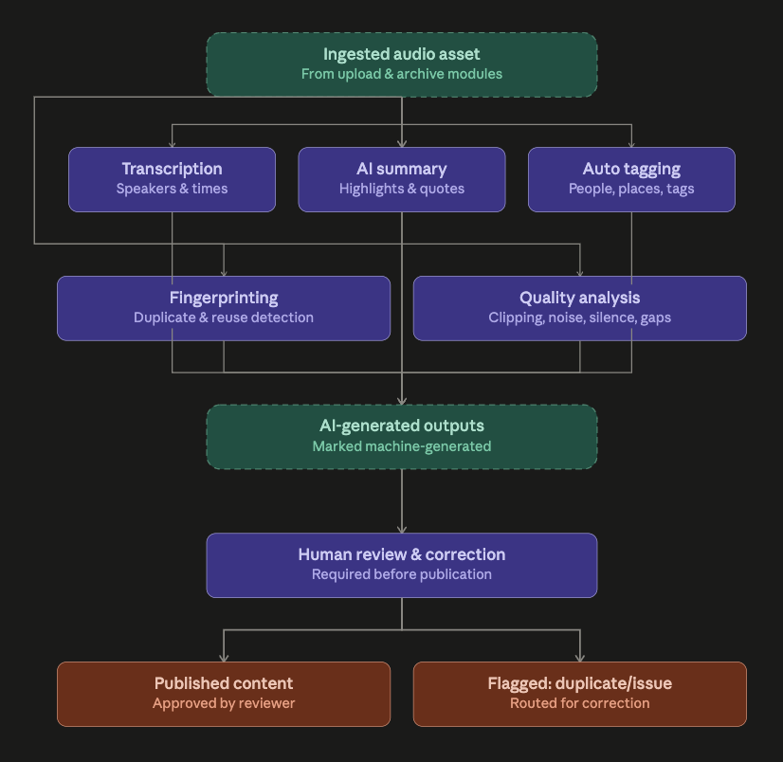

5.17 Approval Workflow Module

This module chains a configurable multi-stage approval workflow (draft → metadata → technical QC → editorial → copyright → management → published/archived) with continuous rights validation — every publish, download, broadcast, or marketing-use action gets checked against active rights period, regional restrictions, commercial-use permission, attribution requirements, and royalty status before it's allowed. Rights alerts (expiring licenses, missing consent, unauthorized commercial use, required removal) run independently of the workflow itself, since rights can lapse on content that's already published.

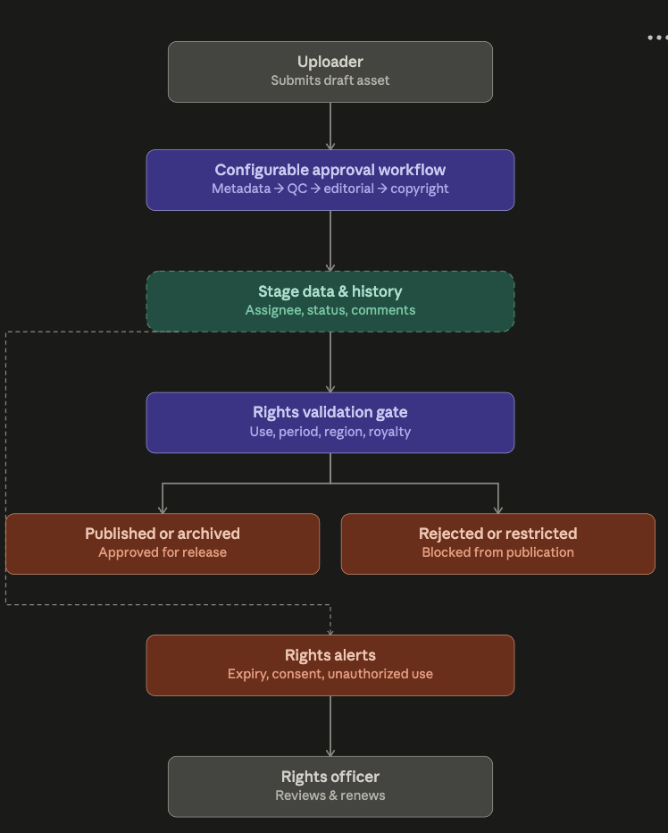

5.18 Broadcasting Operations
An enterprise broadcasting layer covers live scheduling, playlist management, studio and presenter resourcing, advertisement insertion, emergency broadcast override, and complete broadcast logging — connecting the archive directly to on-air operations.
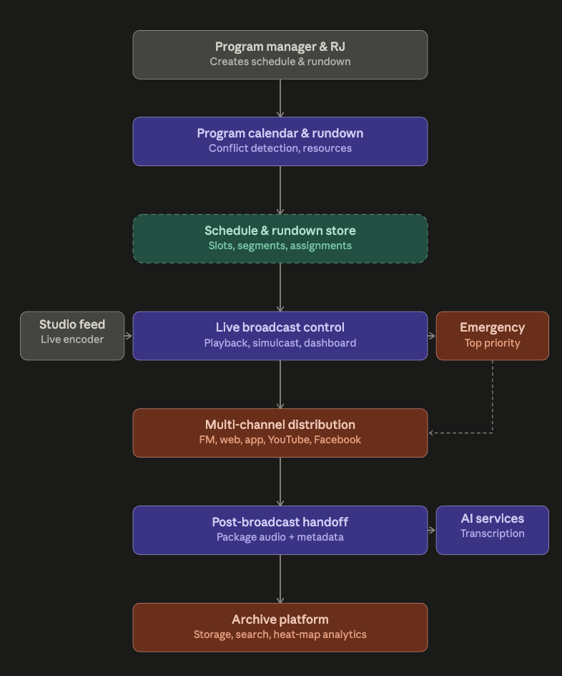

5.19 Audio visualizer and audio-visual content module

This is the richest presentation layer in the platform: every song, podcast, Bhoot FM episode, ad, and voice recording gets an interactive visual (waveform, spectrum, spectrogram, equalizer) with click-to-seek, zoom, markers, and a heat-map overlay driven by real listener-event data — never internal preview traffic, and never shown publicly on restricted content. On top of that sit synchronized lyrics/transcripts/chapter markers, a full audio-visual (video) archive with adaptive streaming and multi-format thumbnail/preview generation, and an audio-to-video promo builder that turns archived audio into shareable social clips (cover image, animated waveform, lyrics, logo, end screen). The one rule threading through all of it: visualization must never modify the original master audio

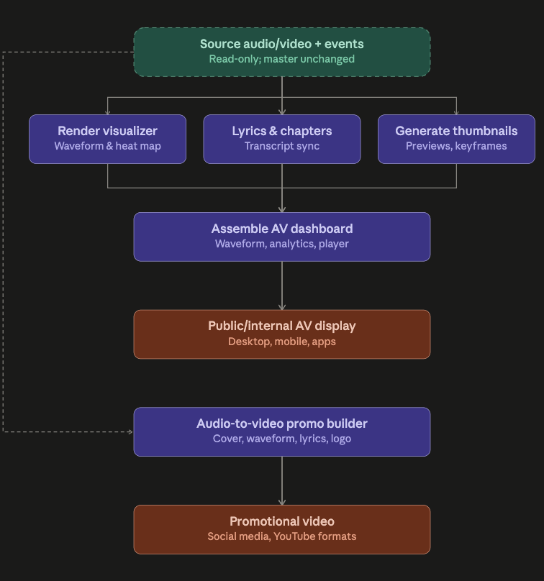

5.20 Public Access, Mobile & Distribution
A public audio portal and mobile application expose approved content to citizens and researchers, while open APIs connect the archive to the Bangladesh Betar website, podcast platforms, social media, YouTube, and government data centres.
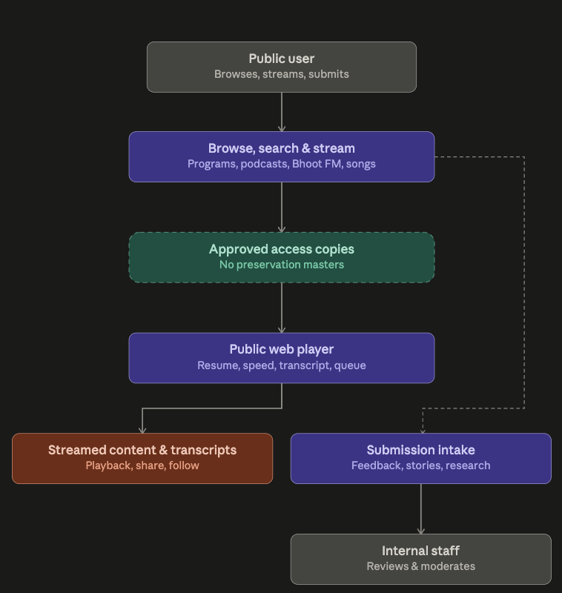
5.21 Dashboard and reports Executive Dashboard
This module is the reporting and alerting layer sitting on top of every other module — six role-specific dashboards (executive, archive, podcast, song, marketing voice, digitization) aggregate data from across the platform, feed 16 exportable report types (PDF/Excel/CSV), while a separate notification engine watches for events across every module (approvals, rights expiry, QC failures, backup failures) and delivers alerts via in-app, email, SMS, or push.
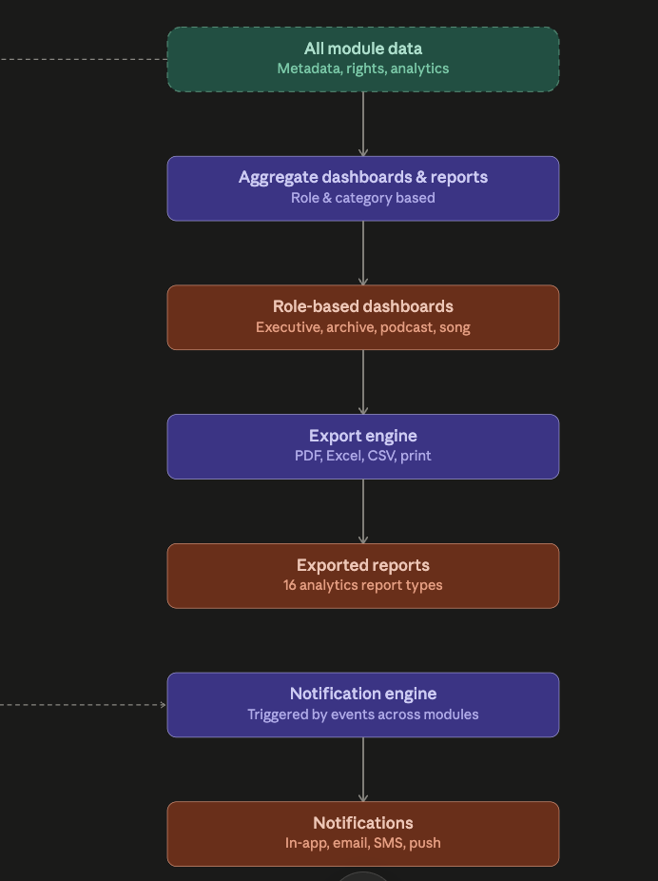

6 Security, Compliance & Preservation
As a national institution handling sensitive government and historical material, the platform applies defence-in-depth security: role-, station- and department-based access, multi-factor authentication and single sign-on, encryption in transit and at rest, watermarked previews, and comprehensive, tamper-resistant audit logging that cannot be edited by ordinary administrators.
Preservation follows a three-copy model — a primary operational copy, a local backup, and an off-site disaster-recovery copy — supported by multi-tier storage, scheduled integrity checks, and automated encrypted backups, ensuring the archive survives both technical failure and time.

7 Delivery Roadmap
A phased delivery approach allows Bangladesh Betar to realize value early while building toward full national scale:
Phase | Focus | Key Deliverables
Phase 1 | Core Archive | User & role management, upload, metadata, search, player, master/derivative versions, QC, approvals, backup
Phase 2 | Music & Editing | Song management, non-destructive editor, artist/album catalogue, playlists, broadcast exports, rights management
Phase 3 | Podcast, Event & Marketing | Podcast platform, event/story archive, marketing voice library, campaign & jingle management, publishing tools
Phase 4 | Analytics | Playback-event capture, heat-maps, most-played dashboard, retention & trending analytics
Phase 5 | Advanced Features | AI transcription, AI metadata, audio fingerprinting, recommendation engine, external platform integration

8 Success Criteria
The platform will be considered a functional success when the following are demonstrably true:
- Content is reliably ingested, classified and version-controlled across songs, podcasts, event episodes and marketing voices, with originals fully protected from overwrite.
- A complete audit trail exists with every action — upload, edit, approval, publication, and access — captured for accountability.
- Heat-maps and most-played dashboards are live showing engagement by date, station, genre and platform.
- Rights and licensing status is enforced automatically and expired-rights content is automatically restricted from use.
- Users can search across metadata, audio content and transcripts, spanning both Bangla and English.
- Approved content can be exported and published in a form suitable for broadcast, web, mobile and social distribution.
- The system operates reliably across multiple stations and departments with audit-ready analytics, rights and usage reporting available to administrators.

9 Conclusion & Recommendation
The Bangladesh Betar Audio Archive Platform should not be scoped as a simple file-storage system. It is, by design, a national Digital Audio Asset Management, Preservation, Production, Rights Management, and Distribution platform — one capable of protecting decades of cultural heritage while powering modern services including podcasts, Bhoot FM distribution, song streaming, voice-over management, public audio access, and mobile applications.
A phased rollout, beginning with the Core Archive in Phase 1, allows Bangladesh Betar to secure its most valuable and at-risk historical recordings immediately, while building toward a fully analytics-driven, AI-assisted, multi-station platform. CraftCode AG recommends proceeding to detailed technical design and Phase 1 planning on this basis.

